Maine Council for Trout Unlimited
Trout Camp - 2023
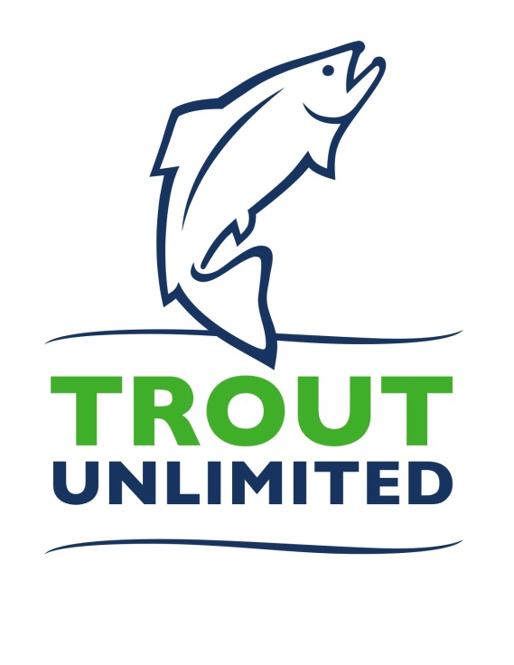
Maine TU Trout Camp is built on a model of other successful Trout Unlimited youth programs around the country. Maine TU Trout Camp is dedicated to educating youth about our cold-water fisheries. Our mission is to build tomorrow’s conservation leaders, giving teens a solid foundation in conservation, entomology, and biology, while keeping it fun and interesting with fly fishing.
Evergreens Campground, in Solon, Maine, will host the camp from June 25th through June 30th. It’s rustic but comfortable cabins provide a true Maine camp experience while offering the comforts of home. Evergreens Campground offers great meals, a spacious area for indoor classes and easy access to the Kennebec River for Fly Fishing and conservation studies. Located 30 miles north of Interstate 95 in Solon, the campground is reached easily while its tall pines create an excellent environment for learning. There will be no student access to wifi or cell service.
The camp is for students from 13-17 who are interested in learning more about fly fishing, fly tying, resource sustainability, effects of climate change, the importance of native fish, and how they can become leaders in these vital areas.
Prospective candidates should complete this application and return it to the President of the TU Chapter in your geographical area. If there’s more information you would like to provide, over and above these seven questions, feel free to include a short essay or video at your discretion. We also request a reference from someone familiar with you personally such as a teacher, counselor, or other group leader. The cost for tuition, room and board is $800. Do not send payment until you confirmed acceptance in for attending the camp. In some cases, scholarship may be provided at the discretion of the individual sponsoring chapters. Equipment will be provided as needed.
Trout Camp Goals:
Learning about Sustainability, Climate Change and Conservation Leadership as well as gaining understanding about Native Fish in Maine.
Questions should be directed to your local chapter or email rcotiaux@gmail.com.
Maine TU – Trout Camp Application
June 25-30, 2023
Name:______________________________________________________________________________
Date of Birth:_____________________________ (Applicants must be 13-17 years of age on 4/15/2023)
Address: Street_________________________________________________
City___________________________________________________
State_________________________Zip_______________________
Telephone:_________________________Email:______________________________________________
Gender: Male________ Female_________
Personal Reference: Name____________________________________________________________
How this person knows you___________________________________________
Phone Number_____________________________________________________
Email_____________________________________________________________
Please answer all of these questions fully. You may use a separate piece of paper.
- Why would you like to attend Trout Camp?

- What do you expect to learn from Trout Camp?

- Do you currently fish. If so which Species?

- Other than fishing, what other outdoor activities interest you?

- Describe an outdoor activity you’ve experienced that you enjoyed the most.

- What do you feel is the most important aspect of conservation in the natural world?

- Are you prepared to function the entire week without phones/social media/email?

